Look up commands

Notes cd (change directory), pwd (print working directory

List examples with documentation with

Absolute path

Ex- cd /home/user/Documents

Relative path

A special directory symbol (. for current directory, .. for parent directory)

A tilde (~)

Exercises

1. Navigate to your home directory.

Cd home

2. List the contents of your home directory.

Ls home

3. Change to the /etc directory.

Cd etc

4. Print your current working directory.

pwd

5. Move back to your home directory using an absolute path.

Cd /home

Notes ls command (list)

Def ls list the contents of the current directory, ls -l list contents in long format, ls –la lists

All files including hiding files in long format, ls –lh /var/log lists contents of /var/log in readable file sizes.

Tree command

Lok up defi e and list 3-5 examples with definitions.

“In computing, **tree** is a recursive directory listing command or program that produces a depth-indented listing of files.”

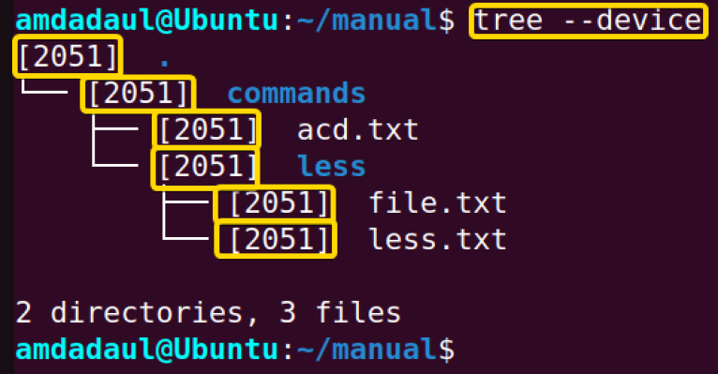

This example lists all of the files and directories on the device with the –device command

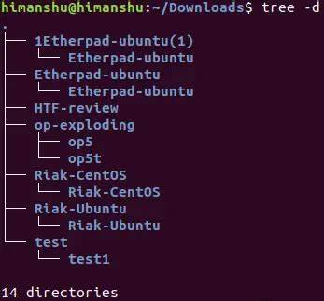

This example lists all of the directories with the –d command

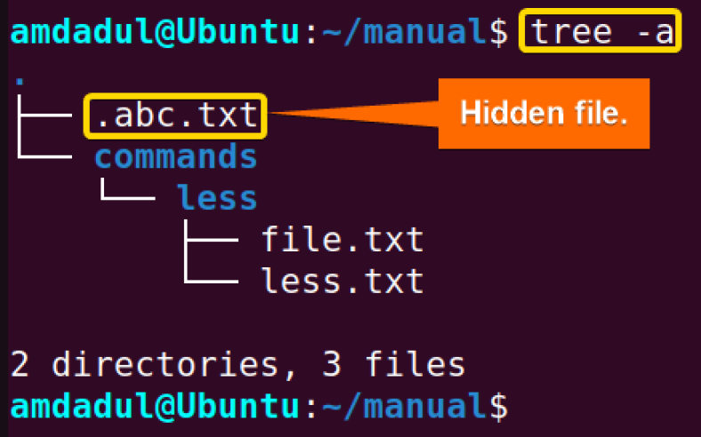

This example lists all files and directories and shows hidden files and directories with the –a command

6. List all files in your home directory, including hidden files.

Ls –la /home

7. Use the long listing format to display files in /etc, sorted by file size.

Ls –l /etc

8. Display the directory structure of /var/log using tree, limiting the depth to 2 levels.

Tree –L 2 /var/log

9. List only the directories in your home directory.

Ls –d /home

10. Use ls to display files in /tmp, sorted by modification time.

Ls –t /tmp